**Testing for convergence clubs in real wage across Indonesian provinces from 2008-2020**

Muhamad Rifki Maulana*, Harry Aginta**

*\* Bank Indonesia, Jakarta - Indonesia.* [*muhamad_rm@bi.go.id*](mailto:muhamad_rm@bi.go.id)

*\*\* Bank Indonesia, Jakarta - Indonesia and Nagoya University, Nagoya - Japan* [*harry_ag@bi,go.id*](mailto:harry_ag@bi,go.id)*;* [*aginta.harry@c.mbox.nagoya-u.ac.jp*](mailto:aginta.harry@c.mbox.nagoya-u.ac.jp)

**Abstract**

This paper aims to empirically evaluate convergence in real wages across 34 Indonesian provinces. We apply the club convergence test (Phillips & Sul, 2007, 2009) on real wage data at the province level from 2008-2020. We do not find overall convergence in real wages. Instead, we identify three significant club convergence. Furthermore, using the ordered logit model, we investigate regional factors that influence the club convergence formation. We find that club convergence formation is jointly influenced by the following factors: share of employment in the manufacturing sector, investment share to GDP, labor force participation rate, and the initial level of wage. Our findings support the evidence of club convergence studies that emphasize the role of the initial condition and regional characteristics on the formation of club convergence. From a policy standpoint, our results should alert national and provincial governments to synchronize policies promoting sound and competitive labor markets across provinces.

Keywords: regional wage, club convergence, ordered logit model, Indonesia

1. **Introduction**

According to modern economic theories, people with indistinguishable talents will obtain equal remuneration in a wholly integrated labor market (Hicks, 1963; Marhsall, 1920). Adhering to the same premise, many studies have tested for wage convergence in the context of broader labor market analysis, taking labor as a factor of production (Galizia, 2015; Rosenbloom, 1998; Rosenbloom & Sundstrom, 2002). According to Dayanandan & Ralhan (2005), given more unrestricted mobility of people (in addition to lower transportation costs and the use of a common currency), testing wage convergence as the price of labor within a country is more reasonable than across the countries. While the existence of wage convergence is generally expected, the absence of convergence at the intra-national level implies the presence of regional imbalances, resources misallocation, and differences in the cost of living (González, 2020).

In Indonesia, analyzing wage convergence is very relevant because it often becomes the main factor for many people to migrate. Based on theory, the economic reason is one aspect that could influence migration, and several approaches that underlie this among them were delivered by Mantra (1992) and Todaro & Smith, (2003). Both agree that economic motives are reasons to migrate, especially migration from rural to urban areas. Indonesian Central Bureau of Statistics (hereafter, BPS) recorded that the population in urban areas in 2020 is 56.7%, increased from 2010, which is only 49.8%. Furthermore, due to substantial urban expansion, which necessitates many workers, that figure is expected to rise to 66.6 percent by 2035. Another report from BPS shows that the number of lifetime migrants in 2019 in Indonesia is up to 29.8 million people with migrant workers of 5.4 million people. Java island dominates the population of migrants in Indonesia, with around 51.2% of lifetime migrants and 56.5% of migrant workers residing in Java. The high number of migrants in Java is mainly influenced by wage conditions, living costs, and living facilities' availability.

Improvements in people mobility due to the rapid development of transportation infrastructure in Indonesia in the last decade add relevance to studying regional wage convergence. For example, the number of airports in Indonesia has increased from 148 units in 2004 to 235 units in 2018. As a result, domestic passenger traffic increased dramatically during that period, rising from 34 million passengers per year in 2004 to 94 million passengers per year in 2018. Similarly, there has also been a rapid development in communication infrastructure due to massive base transceiver station (BTS) construction built by Indonesia's telecommunication state-owned enterprise from only around 26 thousand units in 2008 to 231 thousand in 2020. This improvement in connectivity is expected to reduce disparity across Indonesian regions in many economic and social dimensions, including wages.

Against this backdrop, the present paper focuses on convergence patterns of the long-run dynamics in wages across Indonesian provinces and the influencing factors of the converging behavior. Despite numerous studies on regional income convergence, little is known about regional wage convergence in Indonesia. Furthermore, this paper uses the average net income per month of employees and laborers in 34 provinces from 2008-2020 as the primary indicator instead of the regional minimum wage (*Upah Minimum Regional* - UMR). In many cases, regional minimum wage is usually influenced by local government policy and other unconditional factors, so it does not optimally represent the real market situation. We also remove the effect of inflation on regional wage by converting the data from nominal into the real term.

By applying the club convergence technique (Phillips & Sul, 2007), we find three significant convergence clubs of regional wage. Interestingly, the composition of the clubs by using real wage is very similar to the one we obtained by using nominal wage, implying the existence of a price-adjusted mechanism in regional wages. Provinces that converge into the higher wage clubs (club 1 and club 2) share similar characteristics; having a large proportion of manufacturing industries and high traffic of migrant workers, and locations of main national strategic infrastructure projects to promote investment. Our further analysis using ordered logit model suggests that the formation of club convergence is significantly explained by the following variables: share of employment in the manufacturing sector, investment share to GDP, labor force participation rate, and the wage level at the initial period. These findings also confirm the assumption of similar characteristics mentioned above.

The remaining part of the paper is organized as follows. Section 2 reviews the related literature, and Section 3 discusses the methodologies and data. We discuss the results of club convergence identification and the influencing factors in Section 4. Finally, Section 5 concludes the paper.

1. **A brief review on wage convergence studies and contribution of the present paper**

In labor market literature, wage convergence is generally evaluated from two perspectives: first, convergence in wage across workers and, second, across locations. Among others, the study of Fang & Yang (2011) is one of the well-appreciated works evaluating wage convergence across unskilled and skilled workers in China. Their results indicate that the wage of unskilled and skilled workers in China has converged, mainly due to the acceleration of structural change in the Chinese economy. Furthermore, the rapid growth in labor demand in China has exceeded the capacity of the labor market to supply, causing the wage of unskilled workers to escalate, known as the Lewis turning point.

On the other hand, however, studies investigating wage convergence across locations have been gaining popularity since the advancements in transportations and communication technologies increase labor mobility (Prado et al., 2020). The notion of free labor mobility across administrative borders is the necessary condition for wage convergence mechanism to work. Regional wage differentials tend to decrease when there are no migration barriers, particularly from low-wage to high-wage regions (Collin et al., 2019).

A collection of studies shows evidence of regional wages convergence concerning flexible labor mobility. For example, using panel data covering 203 NUTS-2 level regions in European Union from 1996 to 2006, Naz et al., (2017) find wage convergence only across internal regions (regions within the same country) but no evidence of convergence for border regions (neighboring regions across international borders). With a similar approach, Enflo et al., (2014) apply panel fixed effect models and show that internal and external migrations contributed to wage convergence across Swedish counties before World War I, where the internal migration mainly during the interwar years.

As shown in other empirical studies, the mechanism of wage convergence across regions assumes that there is a significant advancement in transportation and communications that can enlarge the scope of the labor market across geographical boundaries. With these theories and empirical backgrounds, it is natural to expect appealing findings from the analyses on regional wage convergence in Indonesia due to the development of transportation and communications infrastructure in the last decade.

The present paper contributes to the existing literature by focusing on wage convergence analysis across regions that can be used to evaluate the degree of labor market integration in Indonesia. Previously, several studies have examined convergence in Indonesia but mainly focused on variables related to income, such as GDP, GDP per capita and total factor productivity (TFP). For example, applying dynamic the panel data approach, Firdaus & Yusop (2009) analyze convergence in income using province-level data of Indonesia. Applying the system GMM estimation technique, they show convergence among Indonesian provinces during the 1983 – 2003 period. However, the convergence speed is relatively very slow (0.29%), much lower than the convergence speed observed in most regional convergence studies: 2% (Barro et al., 1991; Barro & Xavier Sala-i-Martin, 1992). Using classical absolute and conditional convergence frameworks, Kharisma & Saleh (2013) analyze income convergence among 26 provinces in Indonesia during 1984-2008. They find a strong indication of absolute convergence and conditional convergence and refer to this evidence as the catching-up process where provinces with lower income levels in 1984 tend to grow faster relative to the provinces with higher levels of income. Based on the system GMM estimation, they also find that the speed of convergence in Java is faster than those outside Java. The other study has been implemented by Vidyattama (2006) using a more extended data set since the 1970's. Evidence from his studies shows that significant changes in specific policies and economic development in Indonesia, including macroeconomic conditions and structural change, affect the pattern of regional income convergence. Using the most recent data available, Aginta et al. (2020) analyze income convergence across 514 Indonesian districts from 2000-2017 using the club convergence framework. Their findings support the view of lack of convergence in per capita income during the post-decentralization era. Finally, Purwono et al. (2021) show that between 2011 and 2017, TFP convergence occurred in 33 Indonesian provinces, with intra-provincial exports having a greater impact on TFP convergence than international exports. Probably the closest study to our paper is the analysis by Aginta (2021), where he identifies club convergence in regional price across provinces in Indonesia and further investigates the conditioning factors influencing club convergence formation. Using CPI data from 2012:01 to 2019:12 aggregated at the province level, he shows the absence of overall convergence in the level of regional prices. Instead, the dynamic of regional prices is characterized by four club convergence. His extended research, which employs ordered logit model, demonstrates that a one-unit change in labor productivity, inflation expectation, consumption growth, and spatial externalities considerably impacts the probability of provinces clustering into a different club.

We have shown that empirical research on wage convergence in Indonesia is scant. The present article attempts to close the research gap by bringing new evidence of regional wage convergence and its influencing factors.

1. **Methods and data**
   1. **Econometric methods**
      1. **Testing for club convergence**

Without the necessity to have co-integration in time series, the log *t*-test developed by Phillips & Sul (2007) can investigate the existence of multiple convergence clubs (Bartkowska & Riedl, 2012). In other words, although the evidence of co-integrated in time series is lacking, it does not automatically disprove convergence. With this advantage, many researchers have applied the method in various convergence analyses on different focuses, including income, productivity, financial development, and other social-economic indicators.

To identify the presence of club convergence on regional wage, in this study, we apply the modern test of club convergence by Phillips and Sul (2007). According to the model, we consider a panel-data variable, for instance, $y_{it}$ is expressed as:

|  |  |
| --- | --- |
| $y_{it}=δ_{it}μ_{t}$ | (1) |

where *i* refers to individual unit ​1, 2, …., *N* across time *t* ​= ​1, 2, …, *T*, $y_{it}$ is the dependent variable, $δ_{it}$ indicates individual unit and time-specific component or a time-varying idiosyncratic element. $μ_{t}$ is not unit-specific and thus characterizes the common pattern of $y_{it}$. The dynamics of the idiosyncratic element, $δ_{it}$, can be expressed as:

|  |  |
| --- | --- |
| $δ_{it}=δ_{i}+\frac{σ_{i}ξ_{it}}{log⁡(t)t^{α}}$ | (2) |

where $δ_{i}$ is a time-invariant individual-specific effect, and $ξ_{it}$ is unnecessarily influenced by time with mean 0 and variance 1 across individual units. Departing from equation 2, the null hypothesis states that convergence exists if all individual units collectively approach the common transition path, such that:

|  |  |
| --- | --- |
| $\lim_{t→∞} δ_{it}=δ_{i}\text{ and }α≥0$ | (3) |

Intuitively, the alternative hypothesis is $H_{A}:δ_{i}≠δ$ for all *i* and $α≥0$. To evaluate the convergence over the long-run time horizon, a relative transition parameter of individual unit, $h_{it}$, is formulated as follows:

|  |  |
| --- | --- |
| $h_{it}=\frac{y_{it}}{\frac{1}{N}\sum_{i=1}^{N}{ }y_{it}}=\frac{δ_{it}}{\frac{1}{N}\sum_{i=1}^{N}{ }δ_{it}}$ | (4) |

Basically, $h_{it}$ represents the specific behavior of individual unit *i* against the cross-sectional average. In the state of convergence under equation 3, $δ_{it}→δ_{i}$, then $h_{it}→1$. This also implies that the cross-sectional variance of $h_{it}$ converges to 0 $(H_{t}$ $→$ 0),

|  |  |
| --- | --- |
| $H_{t}=\frac{1}{N}\sum_{i=1}^{N}{ }{\left(h_{it}-1\right)}^{2}→0, t→∞$ | (5) |

where $H_{t}$ $= σ_{t}^{2}$.

To empirically investigate the presence of convergence, the null hypothesis is tested with log t regression model based on the variance ratio $\frac{H_{1}}{H_{t}}$:

|  |  |
| --- | --- |
| $\begin{aligned}&\log\left(\frac{H_{1}}{H_{t}}\right)-2 log⁡\{log⁡(t)\}=a+b log⁡(t)+ϵ_{t} \\ &\text{ for }t=[rT],[rT]+1,…,T\text{ with }r ∈(0,1)\end{aligned}$ | (6) |

From the Monte Carlo simulation, Phillips & Sul (2007) argue that setting $r=0.3$ is recommended. The null hypothesis is rejected when $t_{b}<-1.65$; if that is the case, the next step is to identify relative or club convergence

* + 1. **Identifying club convergence**

The method of Phillips and Sul (2009) can identify if different club convergence exists in the sub-sample in the absence of overall convergence in the full sample. Hence, after testing overall convergence using log t regression, we use the clustering algorithm of Phillips and Sul (2009) for club convergence identification. A summary of this clustering algorithm is in Appendix 1.[1]

* + 1. **Investigating conditioning factors of club convergence**

The literature proposes an important discussion on the conditioning factors of club convergence from two different convergence perspectives. On the one hand, the club convergence hypothesis emphasizes the importance of the initial condition for an economy's transition. On the other hand, conditional convergence argues that structural characteristics completely affect the long-run growth path, while the initial condition is exogenous (Von Lyncker & Thoennessen, 2017).

Although the club convergence method by Phillips & Sul (2007) clusters individual units according to their transition path estimates, it does not explain the factors that drive club formation as Azariadis & Drazen (1990) and Galor (1996) specify as club convergence hypothesis. To complete our analysis, we investigate the conditioning factors of club convergence formation.

For this purpose, similar to Bartkowska and Riedl (2012), we apply the ordered logit model. Based on theoretical considerations discussed previously, we test both initial condition and structural characteristics as the explanatory factors in the estimation.

In practice, we denote each club convergence as $c$ = 1, 2, … $c$, where $c$ is categorical according to the number of club convergence identified. Since the method of Phillips & Sul (2007, 2009) ranks the clubs according to the long-run trend of each individual in the respective club, we are allowed to arrange $c$ as an ordinal variable. We assume that there is an unobserved variable $y_{t}^{*}$ that is related to the long-run wage dynamics of provinces that force provinces being clustered in a certain club. Thus, we can write the specification as

|  |  |
| --- | --- |
| $$y_{t}^{*}=X_{i}β+ϵ_{t}$$ | (9) |

where $X_{i}$ is a vector consisting potential explanatory variables for club convergence membership, with $i=1,…,34,$ indicating the province and $ϵ_{t}$ have a logistic distribution. The model uses a maximum likelihood (ML) estimator to compute the probabilities of observing values of $c$. Note that although one can assess the directional effect of explanatory variables towards club membership with the sign of $β$ coefficients, the magnitude does not contain any economic information. Therefore, in addition to the directional information given by the sign of $β$ coefficients, we further compute the marginal effects of a given unit change in each explanatory variable on predicted probability, holding other variables constant.

* 1. **Data**

As a proxy of regional wage, we use the average of net nominal income per month received by a general worker (in thousand IDR) published by BPS. According to BPS, the net nominal income per month is defined as remuneration received during the last month in the form of money or goods received by a person considered an own-account worker, a casual employee in agriculture, or a casual employee non-agriculture sector. The original wage data is in nominal terms, and its statistical measurement is uniform across provinces and consistent over time. Ideally, to reflect labor’s purchasing power differential across provinces, the nominal wage should be deflated using the estimated absolute cost-of-living of each province, similar to the approach used by Collin et al., (2019). However, due to data limitation at province level, we could not estimate the absolute cost-of-living. Instead, we deflate nominal wage using provincial Consumer Price Index (CPI) of 2005 as the base year (2005=100).[2] In this way, we remove the nominal effects from the change in regional wage over time, but we acknowledge that our real wage data does not reflect regional variation in labor’s purchasing power. Fig A1 in the Appendix demonstrates the evolution of provincial real wage across time, and the summary statistics is provided in Table A1 Appendix.

1. **Results and discussion**
   1. **Regional wage disparities across Indonesian provinces**

Before implementing the club convergence test, it is important to document the dynamics of wage disparity across provinces over time. Fig 1 plots the coefficient of variation (CV) of regional wage, both in real and nominal terms. The plot clearly shows the absence of sigma convergence in both regional real and nominal wage, that is, the dispersion of wage in the final period is higher than in the initial period.[3] Interestingly, the trend of regional wage dispersion in Indonesia is different from that in China and India. As shown in Fig 2, dispersion in regional wage in these two developing and most populated countries in Asia exhibits a declining trend during the same observation period. Although the difference in regional wage disparity at the end of the period is relatively subtle (0.185 in China, 0.205 in Indonesia, and 0.216 in India), the difference in the long-run trend is more recognizable, with regional wage disparity in Indonesia being more persistent than in China and India.

|  |  |
| --- | --- |
|  |  |
| Fig. 1. Dispersion of regional real and nominal wage in Indonesia, 2008-2020 | Fig. 2. Dispersion of regional nominal wage in China and India, 2008-2019[4] |

We also illustrate the evolution of regional wage disparities among Indonesian provinces over the years. As seen from Fig 3, generally, the quantiles of the distribution show persistent gaps over time, indicating the tendency of steady regional wage disparities, similar to what is shown in Fig 1. In particular, the persistent gap between quantile 95 and the rest of quantiles and the widening gap between quantile 75 and quantile 50 after 2017 implies a systematic difference between high-wage provinces and the rest of provinces that might be related to the structural differences. This dynamic of quantiles distribution in provincial wage helps us understand that there is strong symptom of lack of convergence in regional wage across Indonesian provinces despite the massive efforts from the government to enhance regional connectivity. However, as discussed in subsection 3.1.2, the econometrics method that we use in the present paper makes it possible to identify club convergence, if any, albeit divergence in the entire sample. Therefore, in the next section, we will test the temporary conclusion of wage divergence with a formal econometric framework.

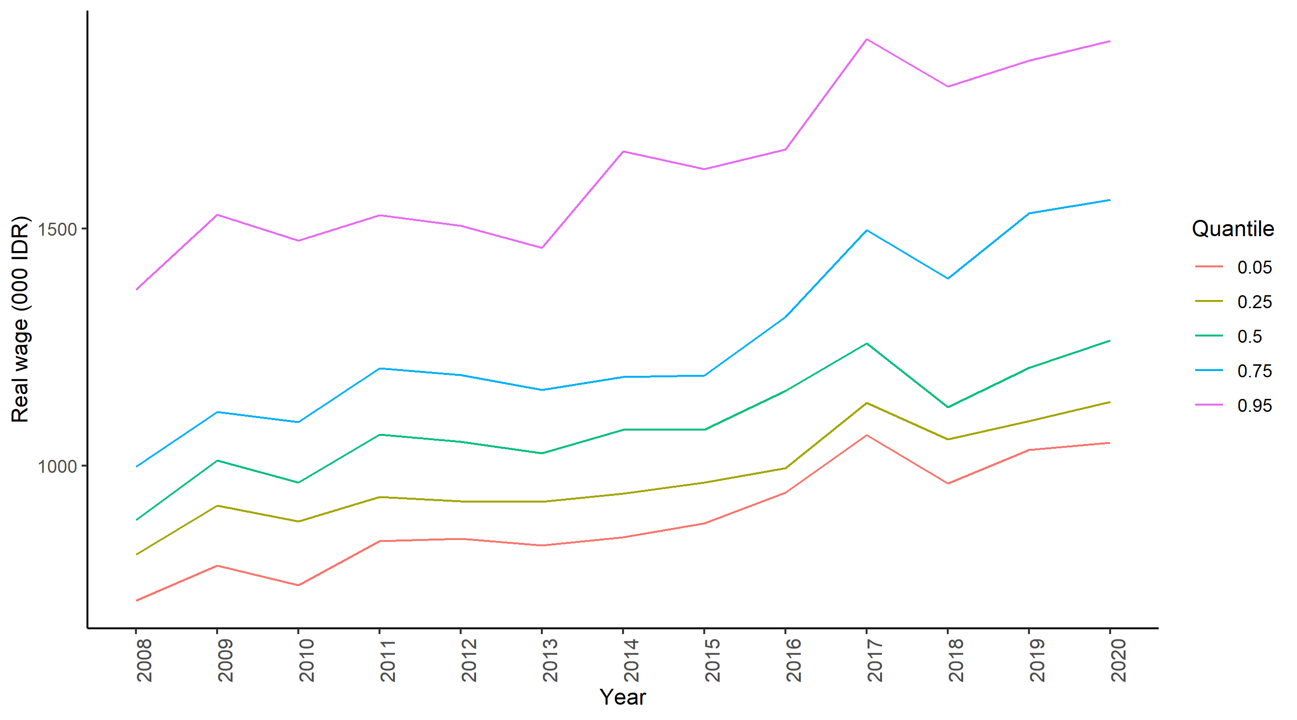

Fig. 3. Dispersion of provincial real wage, 2008-2020

* 1. **Testing and identifying for convergence clubs**

We begin the formal test for convergence by applying log *t* regression on real wage across 34 Indonesian provinces over the 2008:01 - 2020:12 period. As reported in Table 1, the results suggest rejecting the null hypothesis of overall convergence. Therefore, we can support our findings from preliminary inspection and conclude that Indonesian provinces do not converge to a common equilibrium in terms of real wage during the observation period. As real wage is partially linked to the price level in each province, this result is consistent with the evidence from previous studies where overall convergence is not observed in regional price dynamics across Indonesia prices (Jangam & Akram, 2019; Aginta 2021). It is important to emphasize that, given the method used to build real wage data in this analysis as described in Section 3.2, the absence of overall convergence from log *t* regression does not necessarily imply divergence in labor’s purchasing power among Indonesian provinces.

Table 1. Test of overall convergence

|  |  |  |  |
| --- | --- | --- | --- |
|  | Coefficient | Standard error | *t*-statistics |
| Log(t) | -1.130 | 0.014 | -79.721 |

*Note:* *t*-statistic < -1.65 implies the rejection of the null hypothesis of convergence.

We continue the analysis with the clustering algorithm by Phillips & Sul (2009) to identify club convergence. Table 2 presents the results.

Table 2. Club convergence test

|  |  |  |  |
| --- | --- | --- | --- |
|  | Club 1 | Club 2 | Club 3 |
| Coefficient | 0.113 | 0.745 | -0.014 |
| Standard error | 0.232 | 0.242 | 0.108 |
| *t*-statistics | 0.486 | 3.081 | -0.126 |
| Number of provinces | 3 | 9 | 22 |

*Note:* *t*-statistic < -1.65 implies the rejection of null hypothesis of convergence.

Club 1: Jakarta, Riau Islands, Banten

Club 2: Papua, East Kalimantan, North Kalimantan, West Java, West Papua, North Sulawesi, Bali, Central Kalimantan, South Sulawesi

Club 3: North Maluku, Riau, Maluku, West Sulawesi, South Kalimantan, Bangka Belitung, Southeast Sulawesi,

West Sumatra, Aceh, Gorontalo, East Java, North Sumatra, Bengkulu, Yogyakarta, Central Java, South Sumatra, West Nusa Tenggara, Jambi, Lampung, Central Sulawesi, West Kalimantan, East Nusa Tenggara

We find three significant initial clubs that represent the convergence dynamics of regional wage across Indonesian provinces.[5] These results are similar to those reported by Neagu (2020) for the Romanian case. Next, we use the merging method of Phillips & Sul (2009) described in Appendix 2 to test whether the initial clubs can merge to their adjacent club and thus generate bigger club convergence. The results from the merging test suggest rejecting the convergence hypothesis in any merging pair ( $\hat{b}$ < 0 and *t*-statistics < -1.65).[6] Hence, we confirm the initial three clubs as the final club convergence. The clubs are ordered from the highest to the lowest wage; club 1 consists of higher-wage provinces, while the lowest-wage provinces are clustered in club 3. As mentioned before, the club convergence method estimates the transition path of clubs and all individual units. Taking this advantage, in Fig 4 we show the evolution of the computed clubs’ transition paths over time. Unlike using the absolute value of wage on Y axes (similar to Fig 3), in Fig 4 we plot the relative transition path of each club to the cross-sectional average of all three clubs. Interestingly, there is an indication of gap reduction between club 1 and club 2 from 2008 until 2012. However, the transition path of club 1 after that exhibited an increasing trend with a significantly higher slope than that of club 2, resulting in a larger gap between the two clubs. In other words, the pattern of expanding differences among the clubs’ transition paths supports the identification of significant club convergence over overall convergence. Instead of forming a converging shape, reflected in smaller gaps between clubs over time, the three transition paths demonstrate increasing dispersion between clubs, where club 1 is systematically above the average, club 2 steadily move from below towards the average, while club 3 is consistently below the average.

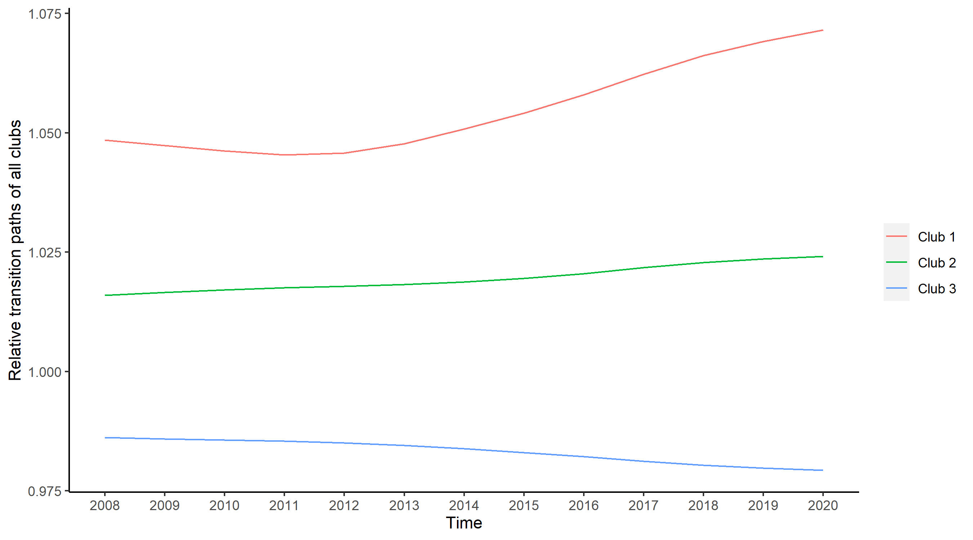

Fig. 4. The transition path of convergence clubs, 2008-2020

We then analyze the within club transition dynamics by plotting the transition path of provinces in each club in Fig 5. Unlike the diverging pattern shown in Fig 4, the transition path in Fig 5 (a), (b), and (c) demonstrate a clear convergence pattern, with a smaller gap between provinces in the final period. In club 1, although real wage in Banten and Jakarta improve over time, the convergence is largely driven by the declining real wage in Riau islands, particularly since 2015. It is worth noting that Riau Islands is renowned as the country's industrial hub, with shipbuilding, oil and gas, and electronics manufacture among its mainstays. Despite its proximity to Singapore, the performance of the islands' industrial sector has deteriorated, with diminishing levels of FDI and exports (Negara & Hutchinson, 2020). On the other hand, Jakarta is the countries’ capital city where large business and financial services are centered, and Banten is a province that shares a border with Jakarta and relies heavily on the manufacturing industry to support its economy (around 37% of GDP).

|  |
| --- |
| 1. Club 1 |
| 1. Club 2 |
| 1. Club 3 |

Fig. 5. The transition path of provinces within each convergence club, 2008-2020

The convergence in club 2 is due to a combination of real wage declines in mining-based provinces (e.g., East Kalimantan, Papua, and West Papua) and improved conditions in the industrialized province of West Java and the newly established province of North Kalimantan. Similarly, the consistent growth of real wages in Java's other two industrialized provinces (Central Java and East Java, respectively, with manufacturing shares of 30% and 34% of GDP) dominates the club 3 convergence process. On the other hand, wage condition in East Nusa Tenggara continues to decline. Agriculture's prolonged dominance – most of which is low-tech and subsistence-oriented – plays a significant role in this phenomenon (*Decent Work Profile East Nusa Tenggara*, 2013).

Finally, we visualize the geographical distribution of club convergence in Fig 6. It is worth noting that we capture geographical effects of club convergence (Barro et al., 1991; Quah, 1996), similar to what has been documented in the study of Aginta et al. (2020) and Aginta (2021) when studying regional income and price convergence in Indonesia. These geographical effects are apparent in Sumatra island, where a province and its neighboring provinces are clustered in the same club (club 3). A similar pattern is also observed in the distribution of club 2 (in Kalimantan and Papua island) and club 1 (where Jakarta and its neighbor Banten clustered together).

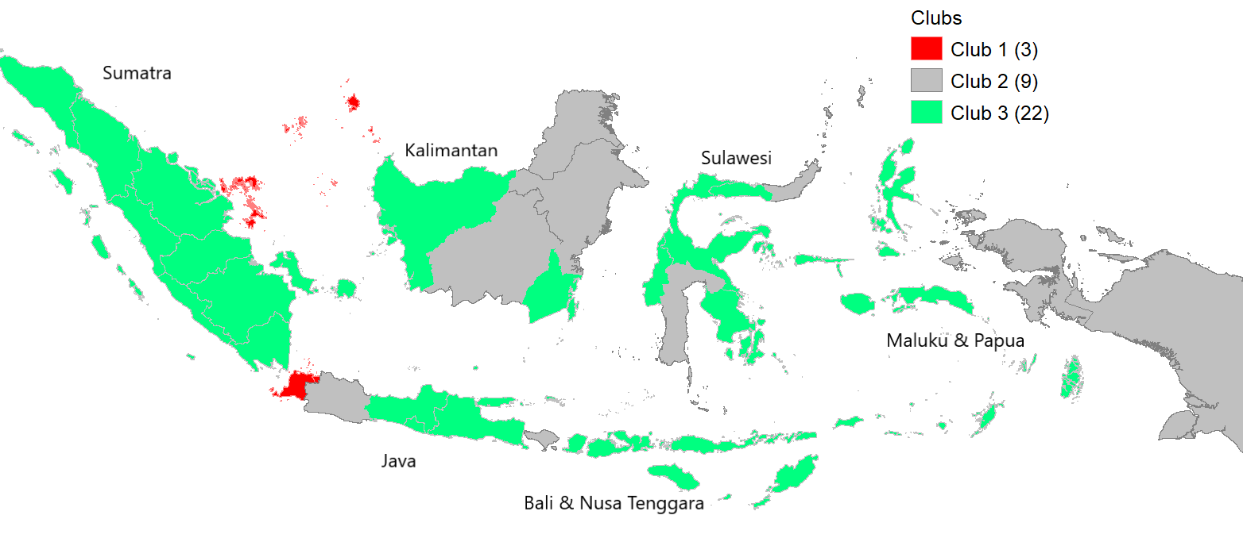

Fig. 6. The geographical distribution of club convergence

The club convergence test results show the presence of a persistent gap in regional real wage across Indonesian provinces. The results also reflect wage rigidity as well as heterogeneity in macroeconomic and labor market conditions across provinces. However, by this far we do not know which components of macroeconomic and labor market conditions explain regional wage disparity across Indonesian provinces. Therefore, in the next section, we investigate the important factors that contribute to the persistent regional wage disparity. More specifically, we aim to provide empirical evidence to address the following question: what regional factors influence the formation of club convergence?

* 1. **Factors influencing the club convergence**

In this section, we examine and discuss important conditioning factors that theoretically influence club convergence formation. The club convergence hypothesis puts a large weight on the crucial roles of the initial condition and structural characteristics in influencing the convergence process; that is, countries or regions will only converge to a common steady-state if they depart from similar initial conditions and share same structural characteristics (Galor, 1996).[7] Therefore, in addition to the level of real wage in 2008 to control for the initial condition, we also include sectoral and labor market indicators to capture the role of structural characteristics in club convergence formation. Not only to be consistent with the theoretical foundation of convergence framework, the selection of variables in our ordered logit model is also comparable with previous club convergence studies (Bartkowska & Riedl, 2012; Cutrini, 2019; Von Lyncker & Thoennessen, 2017).

The ordered logit specification requires variables to be explained in an ordinal manner (McKelvey & Zavoina, 1975). Hence, we re-arrange the clubs by using the wage level of each club as a reference to order the clubs from club 1, club 2, and club 3 as high-wage, middle-wage, and low-wage clubs, respectively. Finally, as in previous literature, we use these ordered clubs as the dependent variable of the regression while independent variables consist of main factors that theoretically influence club convergence. Table 3 contains the definition and sources of variables.

Table 3. Variables in ordered logit estimation

|  |  |  |
| --- | --- | --- |
| Variable | Definition | Source |
| Initial value of wage (2008) | Real wage in 2008 (in 000 IDR) | BPS |
| Manufacture employment share | $$\frac{Number of people employed in manufacturing sector}{Total number of people employed}$$ | BPS |
| Investment share to GDP | $$\frac{Total investment}{Total GDP}$$ | BPS |
| Labor force participation rate | $$\frac{Number of persons in the labor force}{Population aged ten (10) years and over}$$ | BPS |
| GDP | Real GDP (2010 = 100) in log form | BPS |

We report the marginal effects on probabilities computed from the ordered logit model in Table 4.[8] The individual marginal effect measures how much the probability of a province being included as a member of a specific club changes with respect to a small change in the explanatory variables. In this way, our results can explain how a unit change in the independent variable affects the probability of provinces clustered into club 2 (middle-wage) and club 3 (low-wage). However, our model can’t precisely compute the marginal effects on probability to club 1 (high-wage). We consider this as the problem of insufficient samples in club 1 (high-wage).[9] Nonetheless, the model clarifies how the selected factors influence the membership of the club of convergence.

Table 4. The results from ordered logit estimation

|  |  |  |  |
| --- | --- | --- | --- |
| Variables | Marginal effects on probabilities | | |
| Club 1 (High) | Club 2 (Middle) | Club 3 (Low) |
| Initial value of wage (2008) | 0.000  (0.000) | 0.009**  (0.004) | -0.009**  (0.004) |
| Manufacture employment share | 0.000  (0.000) | 0.189**  (0.106) | -0.189**  (0.106) |
| Investment share to GDP | 0.000  (0.000) | 0.162**  (0.078) | -0.162**  (0.078) |
| Labor force participation rate | -0.000  (0.000) | -0.046**  (0.022) | 0.046**  (0.022) |
| GDP (*in logs*) | 0.000  (0.000) | 0.242  (0.211) | -0.242  (0.211) |
| Number of provinces | 3 | 9 | 22 |

*Note*: Numbers in parenthesis are the standard errors. \*\*\**,* **, * show significant level at

1%, 5%, and 10%, respectively. *Source:* Authors’ computation

All ordered logit coefficients show the expected signs. In addition, the magnitude of coefficients deserves special attention. Our results point to the significance of structural characteristics in explaining the club convergence formation.[10] Specifically, the share of employment in the manufacturing sector is the most important structural element driving club convergence. One point increment in the manufacturing employment ratio would significantly raise the probability of a province converging to the middle-wage club (club 2) by 18% while reducing the likelihood of a province converging to the low-wage club (club 3). In this respect, our findings appreciate the conventional view that claims labor productivity is generally higher – therefore, higher wage – in the manufacturing sector. The investment share to GDP and labor force participation rate are the other important structural determinants, to a lesser extent than the share of employment in the manufacturing sector but larger effect than the initial level of real wage in 2008. Overall, our results imply that the mechanism of club convergence formation in real wage across Indonesian provinces mainly works through underlying attributes in regional labor market conditions. Next, we elaborate on the effects of each factor in more detail.

Manufacture employment share has a positive effect for club 1 and club 2, while it shows a negative effect for club 3, which means the province with a higher manufacturing employment share has a higher wage than the rest. This result is also consistent with the finding of Felipe et al. (2019) in which high-tech manufacturing firms generally pay higher wages in Indonesia. Furthermore, they also reveal that differences are likely due in part to differences in skill requirements of the manufacturing sector, with average levels of education and training significantly higher. Moreover, the high productivity rate in the manufacturing sector often becomes the main reason labor in the manufacturing sector often earns a higher wage than labor in other sectors. Strain (2019) finds evidence that there is a strong linkage between productivity and wages. In detail, he describes that when properly measured, productivity and compensations show very similar trends in the last few decades.

Similar to the share of manufacturing employment, the investment to GDP ratio also demonstrates a positive effect towards higher wage clubs. This result is also similar to the finding of Baskoro et al. (2019), which concludes that the relatively higher wage in Foreign Direct Investment (FDI) companies is possibly explained by the higher productivity of labor, which represents an improvement of labor skill and in line with the shift of Indonesian industrial character. Lipsey & Sjoholm (2001) highlight the higher level of education of workers in foreign-owned firms as the main factor explaining why foreign-owned firms in Indonesia might pay a high price for labor. Another reason is that foreign-owned firms wish to reduce employee turnover to secure their technological advantages from being copied by their competitors. The significance of investment in affecting regional wage also implies regional imbalance in economic development where investment activities are largely concentrated in a few provinces with better infrastructure, strategic geographical position, and natural resource endowment. For example, provinces like Jakarta, Banten, and Riau islands are in club 1 and have better infrastructures than other provinces. These provinces also have strategic geographical location which surrounded by well-managed transportation infrastructure, and thus will induce higher labor and capital mobility.

On the other hand, labor force participation rate shows different effect in which the sign of the coefficient is negative in club 1 and club 2 while positive in club 3. This means that a higher labor force participation rate decreases the probability of being in higher wage clubs, reflecting the standard labor supply and demand condition. Higher labor supply relative to its demand leads to downside pressure on wage. Similar to what is mentioned by Herr (2002), we find evidence of negative relationship between wage and labor supply.

The initial wage level shows a positive effect for club 1 and club 2, which means the probability of the province belonging to club 1 and club 2 is higher when the province had a higher initial wage level. Inversely, the negative effect for club 3 means that the province with a higher initial value of wage has a small probability of belonging in club 3. The effect of the initial condition in our study is also in line with the finding of Bartkowska & Riedl (2012), which shows that the region's initial state plays a crucial role in the European areas to determine which club they will belong to.

As for the last variable, although statistically insignificant, the size of economy, or GDP, shows a positive effect on higher-level wage clubs. This implies that the cross-sectional variation in regional wage in Indonesia is less connected to the size of the economy. Instead, regional economic and labor market structures are the main factors that shape the level of regional wage.

1. **Conclusions**

This paper aims to empirically investigate the convergence of regional wages in Indonesia, a large and geographically diverse developing country. Specifically, we address two crucial questions in our empirical analysis. First, can we identify club convergence in regional wage in Indonesia despite the presence of prolonged wage disparity? Second, to what extent, regions specific characteristics influence the formation of club convergence? To achieve the goals, we divide our strategy into two main steps. First, using log *t* regression developed by Phillips & Sul (2007, 2009), we test whether regional wage converge to a common steady state. In the absence of overall convergence, we further check for the presence of club convergence. Second, we investigate essential factors that influence club convergence formation.

Our results from the first step show three significant clubs representing the convergence dynamics of regional wage across Indonesian provinces; three provinces clustered in club 1; nine provinces in club 2; and twenty-two provinces in club 3. Overall, the results from our initial investigation imply that based on the long-run dynamics of regional real wage from the 2008-2020 period, Indonesian provinces can be clustered into three club convergence. The presence of club convergence from our result is similar to the finding of Neagu (2020) in the context of regional wage analysis in Romania.

In the second part, the results from the ordered logit model show that regional characteristics related to labor market conditions largely explain the formation of club convergence in provincial wages. The variables such as manufacture employment share, investment to GDP ratio, labor force participation, and the initial condition of wage significantly influence the convergence club formation, while the size of the economy, or GDP, exhibits insignificant effects. Our findings are not only compatible with the theoretical underpinnings of the convergence concept, but they are also comparable to the previous club convergence investigations (Bartkowska & Riedl, 2012; Cutrini, 2019; Von Lyncker & Thoennessen, 2017).

Taken together, our results suggest four key points concerning policy implications in reducing wage disparity across Indonesian provinces. First, it is imperative to promote the development of manufacturing industries throughout all provinces. Manufacturing sectors would attract skilled workers from different places and could bring positive technical spillovers to local workers. In turn, this would create a trickle-down effect that tends to help reduce wage disparity, as in the case of India (Jain, 2018). Second, boosting investment is equally important, not to mention attracting inward FDI. Technology spillovers and demand creation effects brought by FDI firms would positively influence the productivity of local firms and workers, leading to improved wage levels. Third, reducing wage differentials across regions requires convergence in education. Therefore, improving education quality in less developed regions should become a priority and promote industrialization and investment to guarantee the provision of educated labor and skilled workers. Finally, the Indonesian government needs, both national and locals, to continue enhancing healthy competition in the regional labor market to promote efficiency in resource allocation across regions.

One limitation of this study, however, is the relatively short observation timeframe to study wage convergence. This may have an impact on the estimation of club convergence, as the power of the log *t*-test falls as the time dimension shortens (Phillips & Sul, 2007, 2009; Von Lyncker & Thoennessen, 2017). Furthermore, based on the geographical distribution of the clubs, one is tempted to conclude that real wage in Sumatra island converge perfectly to club 3, except Riau islands. This might not be the case when the spatial unit used is district level, as observed in the context of regional income convergence in Indonesia (Santos-Marquez et al., 2021). Hence, future studies could investigate regional wage convergence at the district level across Indonesia, subject to data availability. Such studies would allow to look more deeply at the role of spatial dependence within a province and between adjacent districts belongs to different provinces in shaping regional wage. Finally, depending on data availability, future research could look into regional wage convergence in Indonesia utilizing real wage data that captures cross-sectional differentials in labor's purchasing power.

**References**

Aginta, H. (2021). Spatial dynamics of consumer price in Indonesia: Convergence clubs and conditioning factors. *Asia-Pacific Journal of Regional Science*, *5*(2), 427–451. https://doi.org/10.1007/s41685-020-00178-0

Aginta, H., Gunawan, A. B., & Mendez, C. (2020). Regional income disparities and convergence clubs in Indonesia: New district-level evidence. *Journal of the Asia Pacific Economy*, 1–33.

Azariadis, C., & Drazen, A. (1990). Threshold Externalities in Economic Development. *The Quarterly Journal of Economics*, *105*(2), 501–526. JSTOR. https://doi.org/10.2307/2937797

Barro, R. J., Sala-i-Martin, X., Blanchard, O. J., & Hall, R. E. (1991). Convergence across states and regions. *Brookings Papers on Economic Activity*, 107–182.

Barro, R. J. & Xavier Sala-i-Martin. (1992). Convergence. *Journal of Political Economy*, *100*(2), 223–251. JSTOR.

Bartkowska, M., & Riedl, A. (2012). Regional convergence clubs in Europe: Identiﬁcation and conditioning factors. *Economic Modelling*, *29*(1), 22–31.

Baskoro, L. S., Hara, Y., & Otsuji, Y. (2019). Labor Productivity and Foreign Direct Investment in the Indonesian Manufacturing Sector. *Signifikan: Jurnal Ilmu Ekonomi*, *8*(1), 9–22.

Collin, K., Lundh, C., & Prado, S. (2019). Exploring regional wage dispersion in Swedish manufacturing, 1860–2009. *Scandinavian Economic History Review*, *67*(3), 249–268.

Cutrini, E. (2019). Economic integration, structural change, and uneven development in the European Union. *Structural Change and Economic Dynamics*, *50*, 102–113.

Dayanandan, A., & Ralhan, M. (2005). Price index convergence among provinces and cities across Canada: 1978–2001. *University of Victoria Department of Economics Econometrics Working Paper*, *504*, 1–15.

*Decent Work Profile East Nusa Tenggara*. (2013). International Labour Organization. https://www.ilo.org/wcmsp5/groups/public/---dgreports/---integration/documents/publication/wcms_228702.pdf

Enflo, K., Lundh, C., & Prado, S. (2014). The role of migration in regional wage convergence: Evidence from Sweden 1860–1940. *Explorations in Economic History*, *52*, 93–110.

Fang, C., & Yang, D. (2011). Wage increases, wage convergence, and the Lewis turning point in China. *China Economic Review*, *22*(4), 601–610.

Felipe, J., Widyasanti, A., Foster-McGregor, N., & Sumo, V. (2019). *Policies to Support the Development of Indonesia’s Manufacturing Sector during 2020–2024: A Joint ADB–BAPPENAS Report*. Asian Development Bank.

Firdaus, M., & Yusop, Z. (2009). *Dynamic analysis of regional convergence in Indonesia*.

Galizia, P. C. (2015). *Mediterranean labor markets in the first age of globalization: An economic history of real wages and market integration*. Springer.

Galor, O. (1996). Convergence? Inferences from Theoretical Models. *The Economic Journal*, *106*(437), 1056–1069. JSTOR. https://doi.org/10.2307/2235378

González, F. A. I. (2020). Regional price dynamics in Argentina (2016–2019). *Regional Statistics*, *10*(02), 83–94.

Herr, H. (2002). *Wages, employment and prices: An analysis of the relationship between wage level, wage structure, minimum wages and employment and prices*. Working Paper.

Hicks, J. (1963). *The theory of wages*. Springer.

Jain, H. (2018). Technological Change, Skill Supply and Wage Distribution: Comparison of High-Technology and Low-Technology Industries in India. *The Indian Journal of Labour Economics*, *61*(2), 299–320.

Jangam, B. P., & Akram, V. (2019). Do Prices Converge Among Indonesian Cities? An Empirical Analysis. *Bulletin of Monetary Economics and Banking*, *22*(3), 239–262.

Kharisma, B., & Saleh, S. (2013). Convergence of Income Among Provinces in Indonesia 1984-2008: A Panel Data Approach. *Journal of Indonesian Economy and Business*, *28*(2), 167–187.

Lipsey, R. E., & Sjoholm, F. (2001). *Foreign direct investment and wages in Indonesian manufacturing*.

Long, J. S., & Long, J. S. (1997). *Regression models for categorical and limited dependent variables* (Vol. 7). Sage.

Mantra, I. B. (1992). Pola dan arah migrasi penduduk antar propinsi di Indonesia tahun 1990. *Populasi*, *3*(2).

Marhsall, A. (1920). *Principles of economics*. Macmillan.

McKelvey, R. D., & Zavoina, W. (1975). A statistical model for the analysis of ordinal level dependent variables. *Journal of Mathematical Sociology*, *4*(1), 103–120.

Naz, A., Ahmad, N., & Naveed, A. (2017). Wage convergence across European regions: Do international borders matter? *Journal of Economic Integration*, 35–64.

Neagu, O. (2020). Real Wage Convergence in Romania: Empirical Evidence Based on Club Converging. *Studia Universitatis Vasile Goldiş, Arad-Seria Ştiinţe Economice*, *30*(3), 108–117.

Negara, S. D., & Hutchinson, F. (2020). Batam: Life after the FTZ? *Bulletin of Indonesian Economic Studies*, *56*(1), 87–125.

Phillips, P. C. B., & Sul, D. (2007). Transition Modelling and Econometric Convergence Tests. *Econometerica*, *75*(6), 1771–1855.

Phillips, P. C. B., & Sul, D. (2009). Economic transition and growth. *Journal of Applied Econometrics*, *24*(7), 1153–1185. https://doi.org/10.1002/jae.1080

Prado, S., Lundh, C., Collin, K., & Enflo, K. (2020). Labour and the ‘law of one price’: Regional wage convergence of farm workers in Sweden, 1757–1980. *Scandinavian Economic History Review*, 1–22.

Purwono, R., Yasin, M. Z., Hamzah, I. N., & Arifin, N. (2021). Total factor productivity convergence of Indonesia’s provincial economies, 2011–2017. *Regional Statistics*, *11*(4), 57–78.

Quah, D. (1996). Twin peaks: Growth and convergence in models of distribution dynamics. *Economic Journal*, 1045–1055.

Rosenbloom, J. L. (1998). Strikebreaking and the labor market in the United States, 1881-1894. *Journal of Economic History*, 183–205.

Rosenbloom, J. L., & Sundstrom, W. A. (2002). The decline in hours of work in us labour markets, 1890–1903. In *Labour Market Evolution* (pp. 175–198). Routledge.

Santos-Marquez, F., Gunawan, A. B., & Mendez, C. (2021). Regional income disparities, distributional convergence, and spatial effects: Evidence from Indonesian regions 2010–2017. *GeoJournal*, 1–19.

Sichera, R., & Pizzuto, P. (2019). ConvergenceClubs: A package for performing the phillips and sul’s club convergence clustering procedure. *The R Journal*.

Strain, M. R. (2019). The Link Between Wages and Productivity Is Strong. *Expanding Economic Opportunity for More Americans, The Aspen Institute*.

Todaro, M. P., & Smith, S. C. (2003). *Pembangunan Ekonomi: Di Dunia Ketiga, Jilid 1*.

Vidyattama, Y. (2006). Regional Convergence and Indonesia Economic Dynamics. *Economics and Finance in Indonesia*, *54*, 197–227.

Von Lyncker, K., & Thoennessen, R. (2017). Regional club convergence in the EU: Evidence from a panel data analysis. *Empirical Economics*, *52*(2), 525–553.

**Appendices**

**Appendix 1: Clustering algorithm for club convergence**

When the results from log *t*-test regression reject the null hypothesis of overall convergence, the application of clustering algorithm introduced by Phillips and Sul (2009) can be applied for club convergence identification. The following steps briefly summarize the mechanism of the algorithm:

1. *Step 1: Ordering based on final observation*

All individual units (in our study, provinces) are arranged in descending order based on their last observation in the time series dimension of the panel

1. *Step 2: The formation of the core group*

Apply log t regression is applied to the first $k$ individual units (provinces), where $2≤k<N$. The core group is established when the $t_{b}>-1.65$. If the $t_{b}$ in the first $k$ unit $<$ $-1.65$, the first unit is dropped the log t regression is applied for the second and third units. This step continues until the condition where $t_{b}$ of the pair units $>$ $-1.65$. In the case where no pairs of units showing $t_{b}$ $>$ $-1.65$ in the entire sample, the conclude that there are no convergence clubs in the panel.

1. *Step 3: Filter the data for club membership*

When the core group of a club is successfully identified, the rest of individual units (provinces) that are not belonging to the core group will be added one at a time and evaluated using log t regression. If the inclusion of additional unit results in $t_{b }<-1.65$, then the club convergence only has the core group. Otherwise, a new group is formed when the $t_{b}>-1.65$.

1. *Step 4: Repetition and stopping rule*

Apply log t regression to the remaining individual units (provinces). If the results suggest to reject null hypothesis of convergence, repeat steps 1 to 3. If there is no core group identified for which $t_{b}>-1.65,$ label the reaming individual units (provinces) as divergent and the algorithm stops.

**Appendix 2: Brief description of the club merging procedure**

Apply log t regression to the first two adjacent groups identified by the initial clustering mechanism. If $t_{b}>-1.65$, a new club convergence is formed from these two groups. Next, repeat the step by adding the next group one at a time until the condition of $t_{b}>-1.65$ holds. If the null of convergence is rejected, conclude that all previous groups converge, except the last added one. Restart the merging algorithm from the club where the convergence hypothesis did not hold.

Table A1. Descriptive statistics of monthly real wage in 34 Indonesian provinces

|  |  |  |  |  |  |
| --- | --- | --- | --- | --- | --- |
| No. | Province | Mean | Std Dev | Min | Max |
| 1 | Aceh | 1,057 | 947 | 968 | 1,231 |
| 2 | Bali | 1,205 | 1,920 | 1,001 | 1,529 |
| 3 | Bangka Belitung | 1,017 | 1,339 | 784 | 1,248 |
| 4 | Banten | 1,371 | 2,831 | 987 | 1,797 |
| 5 | Bengkulu | 1,049 | 685 | 955 | 1,178 |
| 6 | Central Java | 885 | 1,484 | 668 | 1,123 |
| 7 | Central Kalimantan | 1,173 | 1,886 | 857 | 1,452 |
| 8 | Central Sulawesi | 989 | 824 | 849 | 1,120 |
| 9 | East Java | 929 | 1,553 | 734 | 1,185 |
| 10 | East Kalimantan | 1,537 | 1,583 | 1,324 | 1,839 |
| 11 | East Nusa Tenggara | 938 | 486 | 880 | 1,037 |
| 12 | Gorontalo | 1,000 | 1,603 | 683 | 1,226 |
| 13 | Jakarta | 1,706 | 3,334 | 1,295 | 2,210 |
| 14 | Jambi | 941 | 975 | 755 | 1,092 |
| 15 | Lampung | 874 | 1,389 | 724 | 1,079 |
| 16 | Maluku | 1,191 | 793 | 1,075 | 1,370 |
| 17 | North Kalimantan | 1,290 | 2,435 | 880 | 1,613 |
| 18 | North Maluku | 1,205 | 1,060 | 985 | 1,373 |
| 19 | North Sulawesi | 1,243 | 2,143 | 929 | 1,571 |
| 20 | North Sumatra | 1,009 | 829 | 872 | 1,142 |
| 21 | Papua | 1,612 | 1,656 | 1,280 | 1,900 |
| 22 | Riau | 1,188 | 976 | 1,036 | 1,322 |
| 23 | Riau Islands | 1,744 | 2,329 | 1,365 | 2,051 |
| 24 | South Kalimantan | 1,066 | 1,402 | 830 | 1,269 |
| 25 | South Sulawesi | 1,145 | 1,978 | 876 | 1,452 |
| 26 | South Sumatra | 987 | 912 | 818 | 1,105 |
| 27 | Southeast Sulawesi | 1,079 | 1,495 | 810 | 1,350 |
| 28 | West Java | 1,233 | 2,490 | 942 | 1,645 |
| 29 | West Kalimantan | 954 | 696 | 845 | 1,077 |
| 30 | West Nusa Tenggara | 936 | 985 | 785 | 1,115 |
| 31 | West Papua | 1,551 | 1,053 | 1,384 | 1,732 |
| 32 | West Sulawesi | 1,170 | 1,304 | 986 | 1,377 |
| 33 | West Sumatra | 1,061 | 990 | 885 | 1,235 |
| 34 | Yogyakarta | 968 | 1,254 | 784 | 1,189 |

*Note:* In thousands of IDR.

*Source:* Authors’ computation.

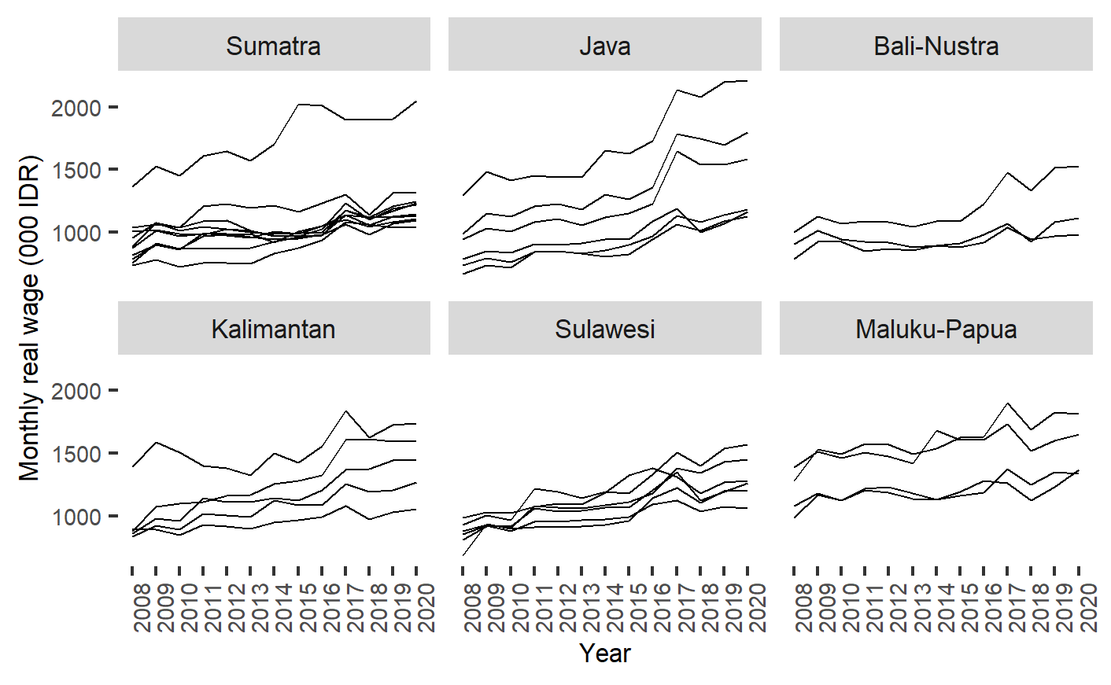

Fig. A1. The time-series of real wage across provinces based on region, 2008-2020

1. See Phillips and Sul (2009) for further detailed discussion.
2. Since the range of our observation is from January 2008 to December 2020, we intentionally select the year outside of our investigated interval as the base year to avoid using of the same wage level (nominal equals real wage) at a particular year.
3. Derived from Barro & Xavier Sala-i-Martin (1992), sigma convergence refers to the decrease in the dispersion of the levels of a given variable across countries or regions over time.
4. CV for China and India is computed from 295 prefectural-level cities and 31 states and union territories, respectively. Regional wage data for China is available until 2018, while the data for India is available until 2019. Data for both countries are collected from CEIC.
5. The evaluation of club convergence is executed using the club convergence package in R developed by Sichera & Pizzuto (2019).
6. We also implement the merging procedure according to Von Lyncker & Thoennessen (2017). The test gives identical results from the merging test of Phillips & Sul (2009).
7. In the context of the neo-classical framework, multiple steady-state equilibria could arise from the variation in factor endowments. In a particular case, the initial level of capital–labor ratio can be used as a proxy of factor endowments that determine the shape of the steady-state path of an economy. On the other hand, economies that use similar production technology tend to evolve toward a common steady state. See Galor (1996) for a more in-depth look at the theoretical models behind convergence clubs.
8. See Long & Long (1997) for a discussion on interpreting the results of ordered logit models.
9. Aginta (2021) and Bartkowska & Riedl (2012) also encounter a similar problem in their respective studies.
10. Cutrini (2019) empirically finds comparable results on the relative importance of structural variables than the initial level of income per capita in influencing club membership across 274 European regions on a NUTS-2 level.